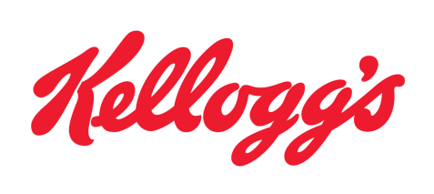
Contact: Hillary Martin FOR IMMEDIATE RELEASE
Tel: (608)846-4776
Cell Phone: (608)669-4342
Email: Martinha@uwm.edu
KELLOGG’S ANNOUNCES THE RELEASE OF ITS 2010 ANNUAL REPORT.
BATTLE CREEK, Mich., March 16, 2011—Today Kellogg’s announced that its 2010 annual report is now available on the Company’s Web site at www.investor.kelloggs.com/annuals.cfm.
“In 2010, internal net sales were down 1 percent; the internal operating profit was flat, and currency neutral EPS rose 6 percent. Over the past 10 years, our reported EPS compounded annual growth rate was 9 percent. We also delivered cash flow in 2010 of approximately $1 billion before a $467 million net-of-tax pension contribution. Through our current $2.5 billion share repurchase authorization and dividends, we maintained our commitment to return cash to our shareowners. In 2010, we purchased just slightly over $1 billion in shares and increased our annual dividend by 9 percent,” said Jim Jeness, Chairman of the Board.
“Finally, our entire industry was impacted by deflationary pressures across the cereal industry due to the economy and widespread promotional activity. Looking ahead, we expect renewed growth in the core cereal business. For Kellogg, we expect net price realization and positive mix across the globe to drive a gradual improvement in sales performance on the top line in 2011.Brand building, along with innovation, has always been one of the essential drivers of creating excitement within our categories and for our brands. Because popular global and local brands drive our success, we will continue our strong investment in brand building,” said John A. Bryant, President and Chief Executive Officer.
Kellogg’s reports net sales of $12.4 Billion, with the dividends per share increasing 4 percent over the past 5 years.
###
About Kellogg Company
For more than 100 years, consumers have counted on Kellogg for great-tasting, high-quality and nutritious foods. Kellogg Company, with 2010 sales of more than $12 billion, is the world's leading producer of cereal and a leading producer of convenience foods, including cookies, crackers, toaster pastries, cereal bars, fruit-flavored snacks, frozen waffles and veggie foods. Kellogg Company's beloved brands, which are manufactured in 18 countries and marketed in more than 180 countries, include Kellogg's®, Keebler®, Pop-Tarts®, Eggo®, Cheez-It®, All-Bran®, Mini-Wheats®, Nutri-Grain®, Rice Krispies®, Special K®, Chips Deluxe®, Famous Amos®, Sandies®, Austin®, Club®, Murray®, Kashi®, Bear Naked®, Morningstar Farm®, Gardenburger® and Stretch Island®. For more information on the Kellogg Company, including corporate responsibility initiatives, visit www.kelloggcompany.com.

