Dear Friends,

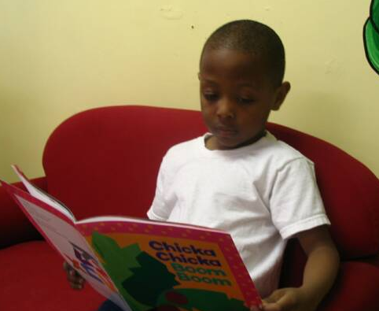So far, 2011 has been a very busy year for us and our many clients. We have provided educational services for children and adults, continued our after school programs for the younger residents, connected with youth groups in the great Madison area, given food to clients that are in need, and provided a better quality of life for those who we serve. Looking back on what we have accomplished from when we started, over 40 years ago, the community center has provided services to more than 1,000 different low income children and adults from the Madison area. In order for us to continue to provide these much needed resources for our clients, we need help from community members like you.

Your help can come in many different forms. As always, we need volunteers to donate their valuable time. There are multiple items on our Wish List that we are always in need of. All of these opportunities can be found in our webpage under the “Get Involved” tab.

Although Wish List items and your time are always valued, today we are writing for your financial support. With your donations, we can make sure that no families are turned away from our services. Donations enable us to increase the quality of life for our residents by providing basic needs that most people take for granted.

Now, more than any other time of year, we need your support. With the school year fast approaching, we must ask for your generosity to obtain essential supplies for our classrooms. Propelling students toward a good education takes a lot of materials. In order for us to provide these supplies while continuing to support our entire community, your contributions are greatly needed.
Help Kennedy Heights to:
- Prepare kids for school
- Get food to families
- Include all residents
- Support healthy choices
- Teach employment skills
- Promote learning
- Increase quality of life for our Madison residents

Your tax-deductable gift will go directly to programs and services for families in Madison. With your financial gift, the Kennedy Heights Community center can continue our critical work in your community. Together we can help make Madison a great place for everyone.

Sincerely,

Alyssa Kennedy
Executive Director
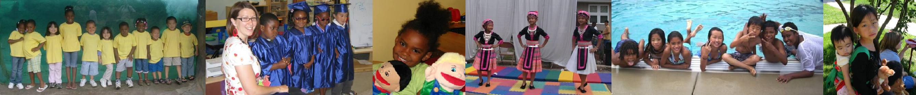
Kennedy Heights Community Center

