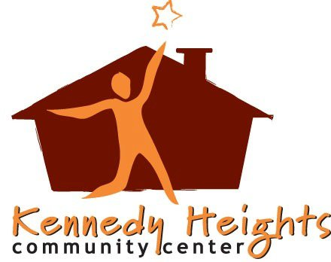
Contact: Hillary Martin FOR IMMEDIATE RELEASE
608-669-4342
KENNEY JOINS KENNEDY HEIGHTS AS EXECUTIVE DIRECTOR
Madison, WI, June 6, 2011— Alyssa Kenney has joined Kennedy Heights Community Center as the executive director. In this role, Kenney will manage the small non-profit, at their Madison, WI location.
Kenney has over 8 years of directing experience in both the education system, as well as the non-profit sector.
A Wisconsin native, Kenney has a bachelor’s degree in Communications and Geography from the University of Wisconsin - Madison.
The Kennedy Heights Community Center is a non-profit organization that is based in the Madison North side. Our community center was made to serve our low to moderate income clients. We cover a wide range of services that support our community members in multiple facets of their lives. We are always looking for volunteers and donations to cover our ever growing needs. Any monetary donations are tax detectable. If you are interested in volunteering or donating, please visit our webpage at www.khcommunitycenter.org
###

